DIGITAL MODULATION TECHNIQUES
In passband data transmission, the digital data modulates high frequency sinusoidal carrier.Hence they are called digital CW modulation techniques. These techniques are suitable for transmission over long distances.
The digital data can modulate the phase, frequency or amplitude of the carrier signal.This gives rise to three basic techniques.
- Amplitude Shift keying(ASK) : In this technique, the digital data modulates the amplitude of the carrier.
- Frequency Shift keying(FSK) : In this technique, the digital data modulates the frequency of the carrier.
- Phase Shift keying(PSK) : In this technique, the digital data modulates the phase of the carrier.
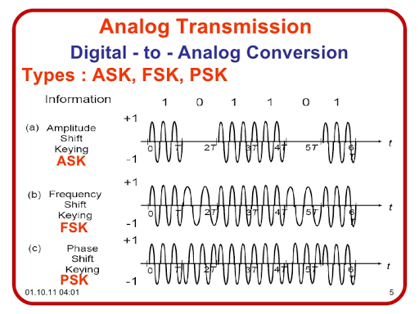

Types of Reception of Passband Transmission:
There are two types of methods for detection of passband signals.
- Coherent (Synchronous ) detection: In this method, the local carrier generated at the receiver is phase locked with the carrier at the transmitter. Hence it is also called synchronous detection.
- Non Coherent (Envelope ) detection:In this method,the receiver carrier need not be phase locked with the transmitter carrier.Hence it is also called envelope detection.This detection is simple but it has higher probability of error.

AMPLITUDE SHIFT KEYING(ASK)
In digital communication, different modulation techniques are used to transmit data or message to receiver over a communication channel . One such technique is Amplitude Shift Keying (ASK). It is a modulation technique that alters the amplitude of a carrier signal to transmit the information over channel. It is a modulation scheme having wide range of application in real world which includes radio, television, and digital data transmission.
Amplitude Shift Keying (ASK) is a type of Amplitude Modulation which represents the binary data in the form of variations in the amplitude of the carrier signal.
Following is the diagram for ASK modulated waveform along with its input.
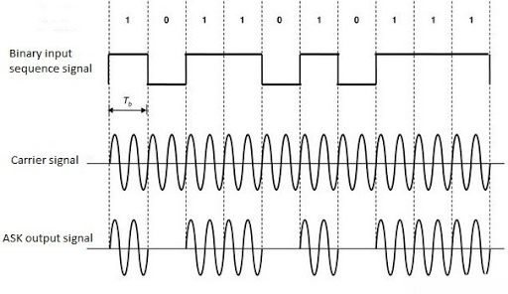
The ASK waveformcan be represented as
$s(t)=\sqrt{2P_{S}}$cos(2П$f_{0}$t) (To transmit ‘1’)
= 0 (To transmit ‘0’)

ASK GENERATION
The ASK generator is shown in fig below:
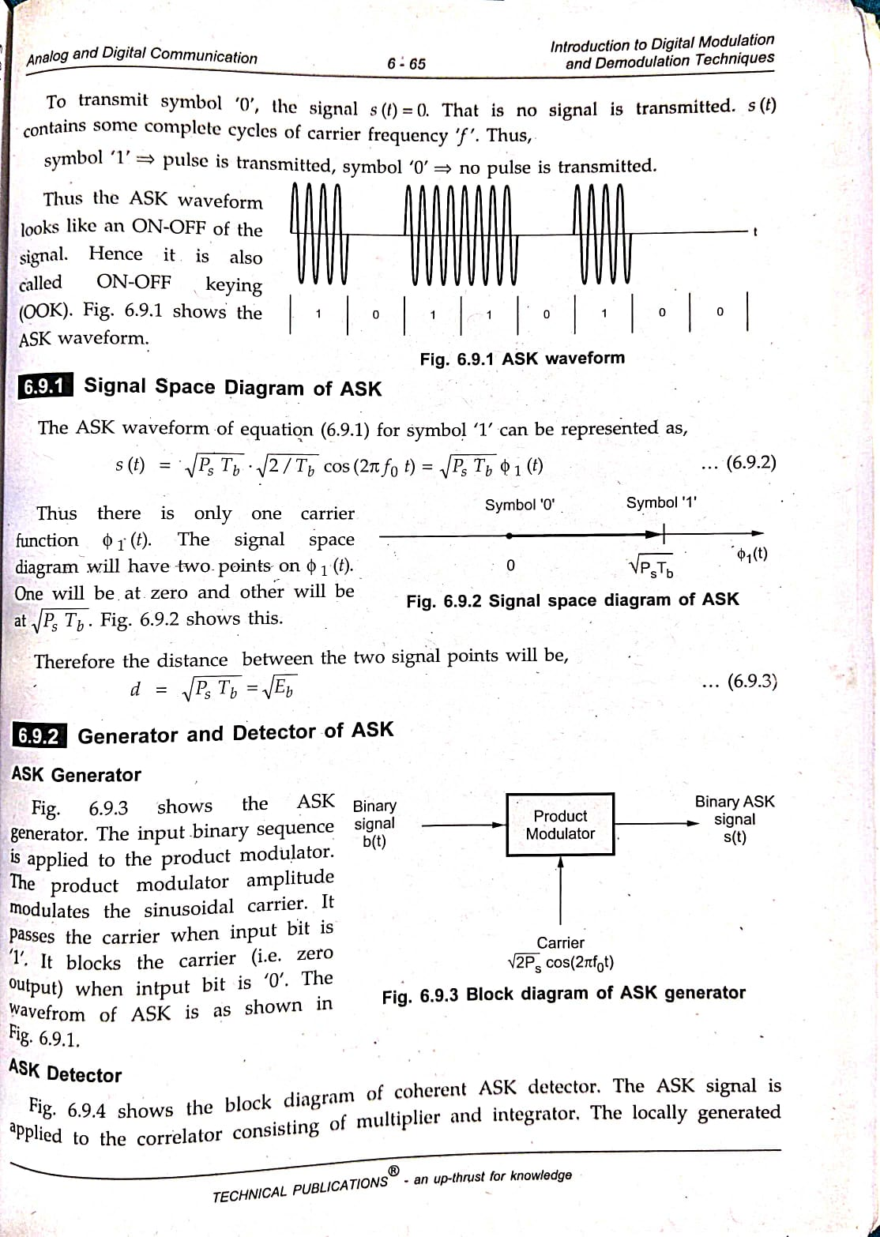
The input binary sequence signal is applied to the product modulator. The product modulator amplitude modulates the sinusoidal carrier. It passes the carrier when input bit is '1'. It blocks the carrier (i.e. zero output) when intput bit is '0'.
ASK DETECTOR
The block diagram of Coherent ASK Detector is shown in fig below:

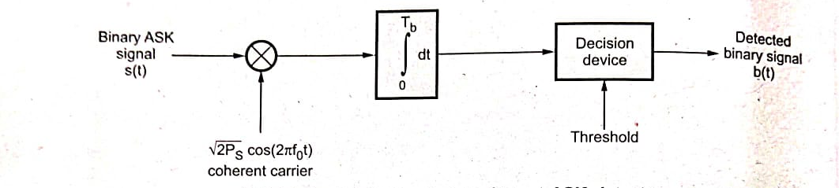
The ASK signal is applied to the correlator consisting of multiplier and an integrator.The locally generated coherent carrier is applied to the multiplier. The output of multiplier is integrated one bit period. The decision device takes the decision at the end of every bit period. It compares the output of integrator with the threshold. Decision is taken in favour of '1' when threshold is exceeded. Decision is taken as '0' if threshold is not exceeded.
BINARY FREQUENCY SHIFT KEYING
The frequency of the output signal will be either high or low, depending upon the input data applied.
Frequency Shift Keying (FSK) is the digital modulation technique in which the frequency of the carrier signal varies according to the discrete digital changes. FSK is a scheme of frequency modulation.

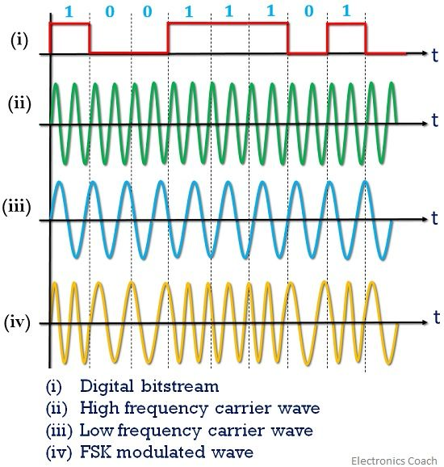

If b(t)=1, $s_{H}$(t)=$\sqrt{2P_{S}}$cos$\left(2Пf_{0}+Ω\right)t$
If b(t)=0, $s_{L}$(t)=$\sqrt{2P_{S}}$cos$\left(2Пf_{0}−Ω\right)t$
Thus there is increase or decrease in frequency by Ω. Let us use the following conversion table to combine above two FSK equations.
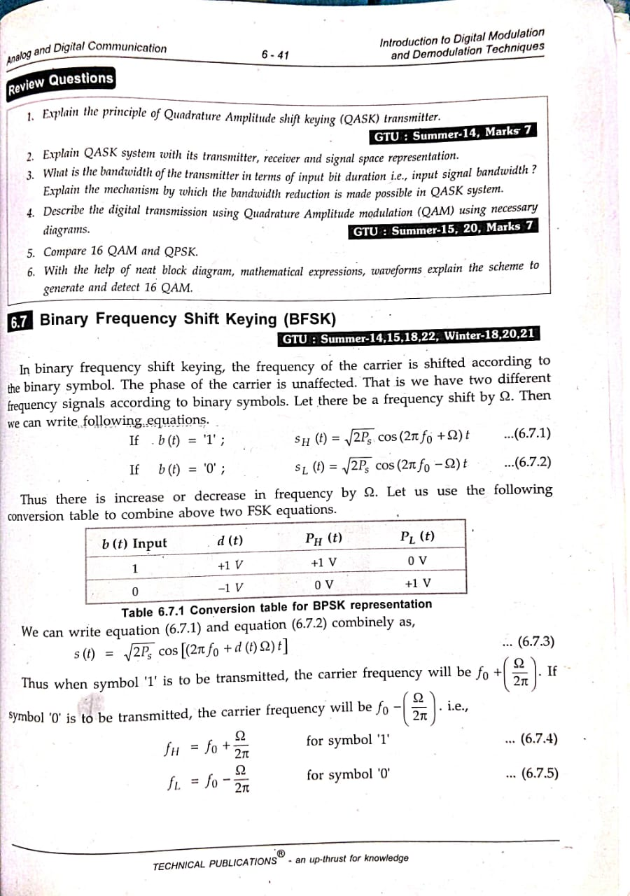
Thus, we can write the above two equations combinely as
s(t)=$\sqrt{2P_{S}}$cos$\left(2Пf_{0}+d(t)Ω\right)t$
When symbol ’1’ is to be transmitted,the carrier frequency will be
$f_{0}$+$\frac{Ω}{2П}$
When symbol ’0’ is to be transmitted,the carrier frequency will be
$$f_{0}−\frac{Ω}{2П}$$
$f_{H}$=$f_{0}$+$\frac{Ω}{2П}$ for symbol ‘1’
$f_{L}$=$f_{0}−\frac{Ω}{2П}$ for symbol ‘0’

BFSK TRANSMITTER
From the table we observe that $P_{H}$(t) is same as b(t) and P_{L}(t) is the inverted version of b(t).The block diagram of FSK Transmitter is shown below
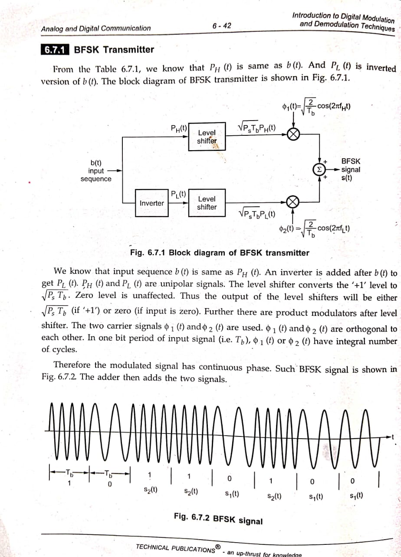
We know that input sequence b (t) is same as P_{H}(t). An inverter is added after b (t) to get P_{L}(t). P_{H}(t) and P_{L}(t) are unipolar signals. The level shifter converts the '+1' level to $\sqrt{P_{S}T_{b}}$. Zero level is unaffected. Thus the output of the level shifters will be either$\sqrt{P_{S}T_{b}}$ (if '+1') or zero (if input is zero). Further there are product modulators after level shifter. The two carrier signals Ⴔ₁(t) and Ⴔ₂(t) are used. In one bit period of input signal (i.e. T_{b}), Ⴔ₁(t) or Ⴔ₂(t) have integral number of cycles.
Therefore the modulated signal has continuous phase. Such BFSK signal is shown in Fig. 6.7.2. The adder then adds the two signals.

Here note that outputs from both the multipliers are not possible at a time. This is because P_{H}(t) and P_{L}(t) are complementary to each other. Therefore if P_{H}(t) =1, then output will be only due to upper modulator and lower modulator output will be zero(since P_{L}(t)=0)
BFSK RECEIVER
The following shows the block diagram of coherent BFSK receiver.
0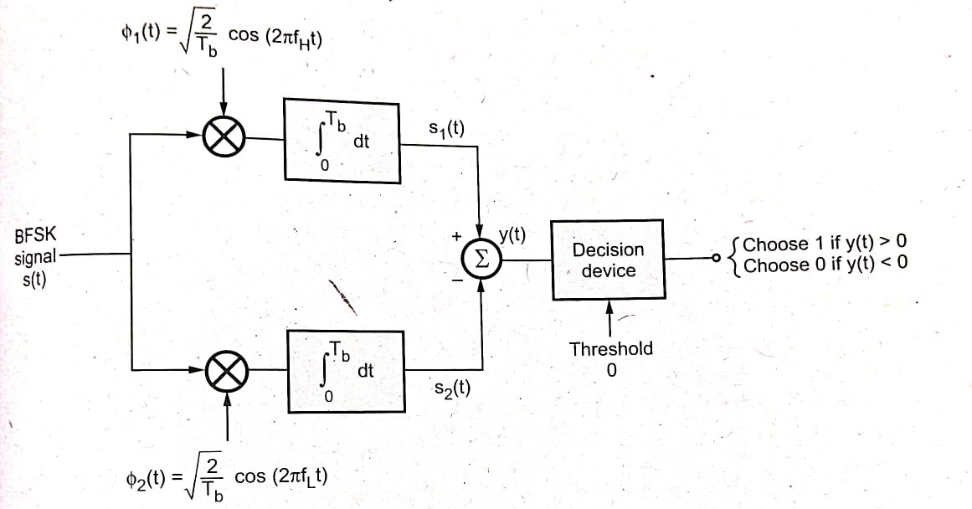
There are two correlators for two frequencies of FSK signal. These correlators are supplied with locally generated carriers Ⴔ₁(t) and Ⴔ₂(t) . If the transmitted frequency is f_{H,} then output s₁(t) will be higher than s₂(t). Hence y(t) will be greater than zero.The decision device then decides in favour of binary ‘1’. If s₂ (t)> s₁(t) then y(t)<0 and decision device decides in favour 0f ‘0’.
Bandwidth of FSK signal=4f_{b} Hz
BINARY PHASE SHIFT KEYING
Binary Phase Shift Keying (BPSK) is a modulation technique employed in communication systems to transmit information via a communication channel. In BPSK the carrier signal is modified by altering its phase by 180 degrees, for each symbol. A phase shift of 180 degrees denotes a binary 0 while no phase shift represents a binary 1. The BPSKs modulation process is straightforward and efficient making it suitable for scenarios where the communication channel suffers from noise and interference.
In BPSK the modulation process involves using a sinusoid as the basis function. By adjusting the phase of this sinusoid based on the message bits we can achieve modulation. When transmitting a 1 there is no phase shift, in the carrier signal. However, when transmitting a 0 there is a phase shift of 180 degrees in the carrier signal. This straightforward modulation scheme enables the transmission of data.
BPSK Waveform:
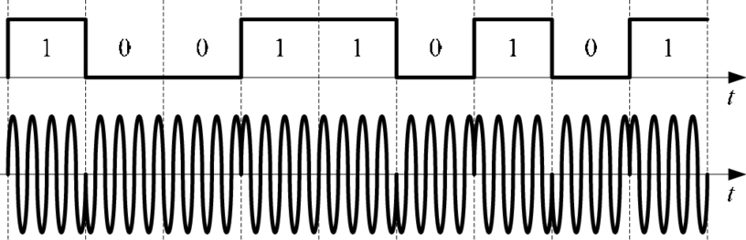
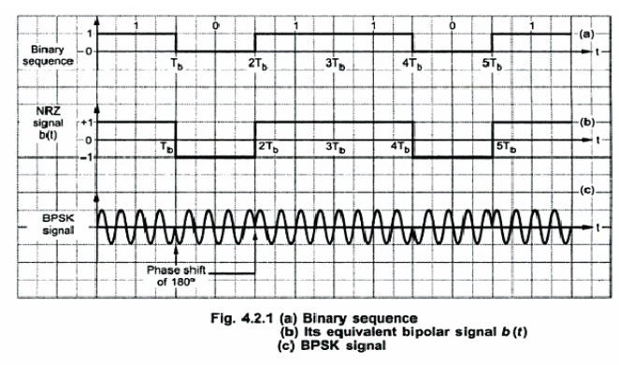

BPSK Transmitter and Receiver
BPSK Transmitter:
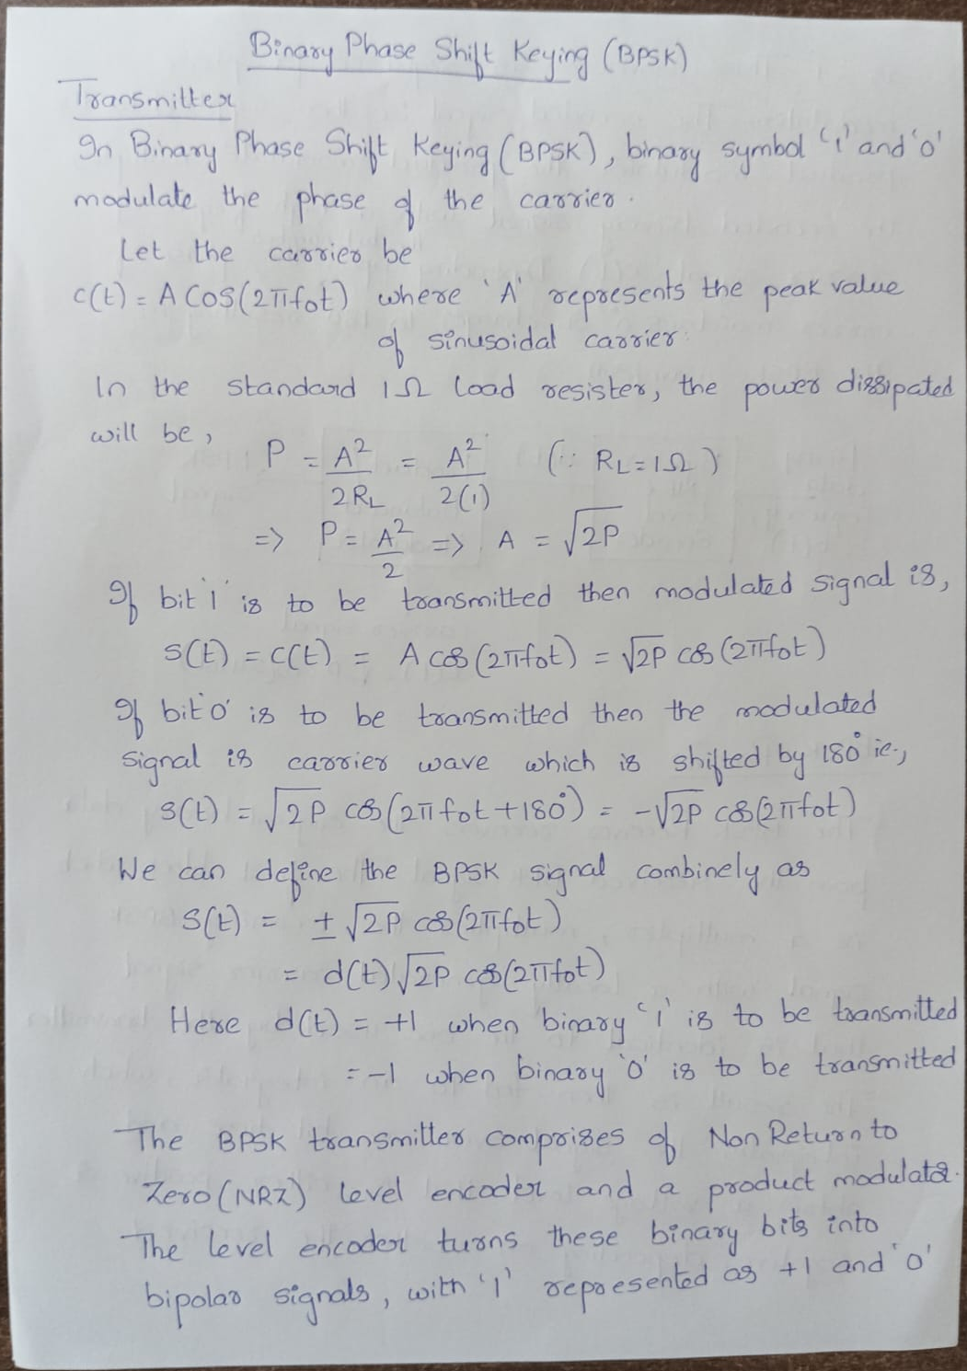
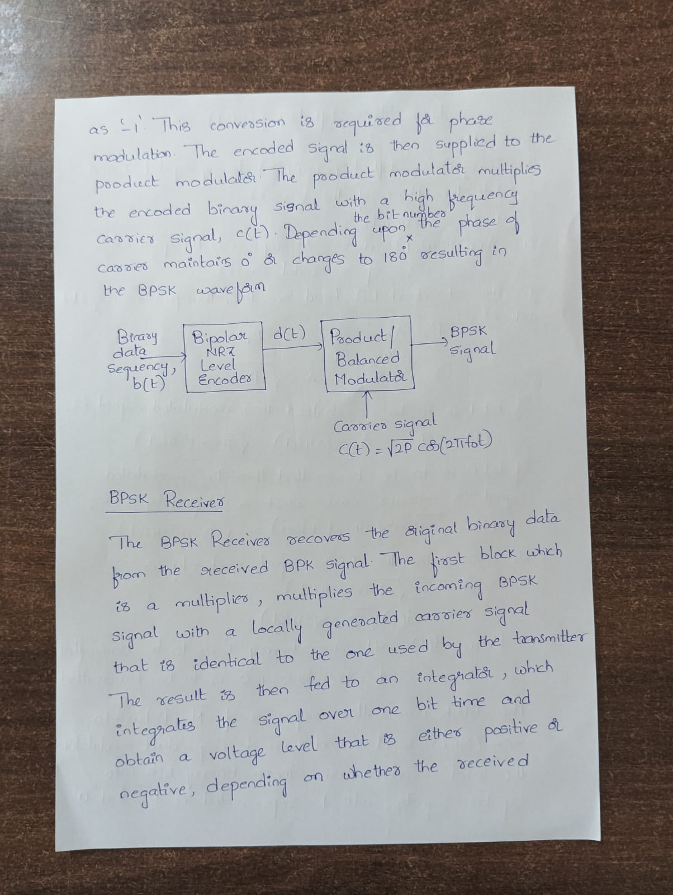

BPSK Receiver

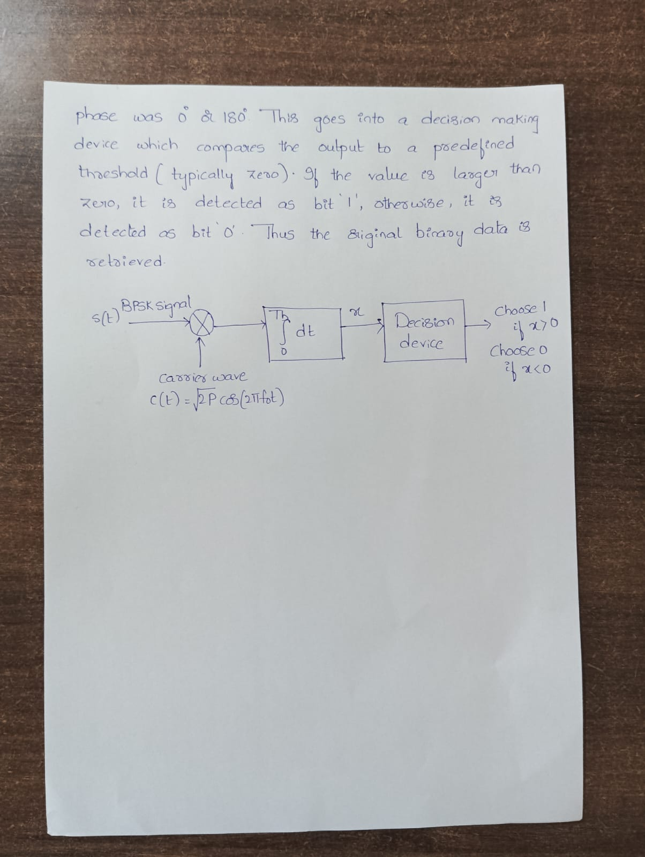

QUADRATURE PHASE SHIFT KEYING(QPSK)
Bit rate referred as number of bits transmitted per second.It is stored in the memory in one and zero format.Symbol is used to map more than one bits and are used to transmit bits over channel after baseband and carrier modulation.Symbol rate is referred as number of symbols transmitted per second. It is also known by "Baud rate".The modulated data after modulation is measured in symbols per sec.
In communication systems we know that there are two main resources, i.e. transmission power and the channel bandwidth. The channel bandwidth depends upon the bit rate or signalling rate f_{b}. In digital bandpass transmission, a carrier is used for transmission. This carrier is transmitted over a channel.
If two or more bits are combined in some symbols, then the signalling rate is reduced. Therefore the frequency of the carrier required is also reduced. This reduces the transmission channel bandwidth. Thus because of grouping of bits in symbols, the transmission channel bandwidth is reduced.
In quadrature phase shift keying, two successive bits in the data sequence are grouped together. This reduces the bits rate or signalling rate(f_{b} ) and hence reduces the bandwidth of the channel.In BPSK we know that when symbol changes the level, the phase of the carrier is changed by 180°. Since there were only two symbols in BPSK, the phase shift occurs in two levels only.
In QPSK two successive bits are combined. This combination of two bits forms four distinct symbols. When the symbol is changed to next symbol the phase of the carrier is changed by 90° (П/ 2 radians). The following table shows these symbols and their phase shifts.
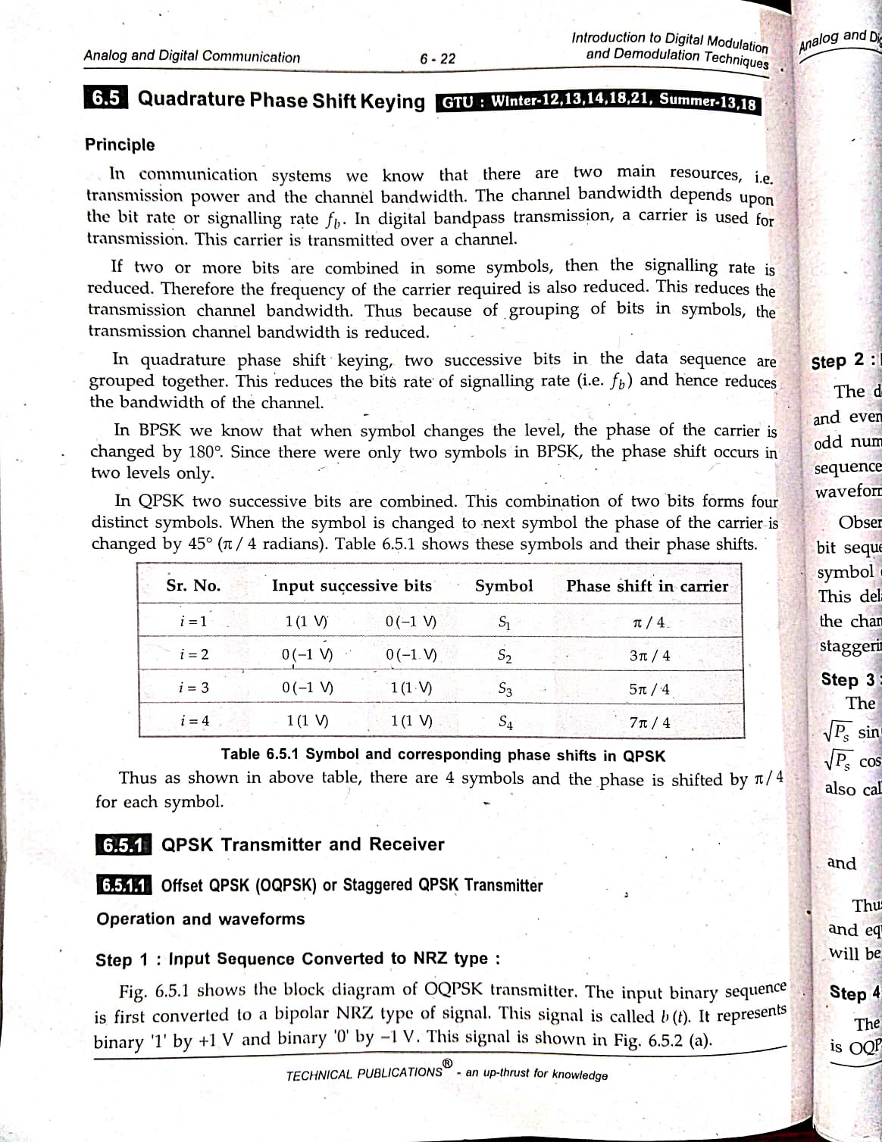
Thus as shown in above table, there are 4 symbols and the phase is shifted by π/2 for each symbol.
QPSK TRANSMITTER AND RECEIVER
Offset QPSK or Staggered QPSK Transmitter
Operation and Waveforms
Step 1: Input Sequence Converted to NRZ type:
The following figure shows the block diagram of OQPSK transmitter.
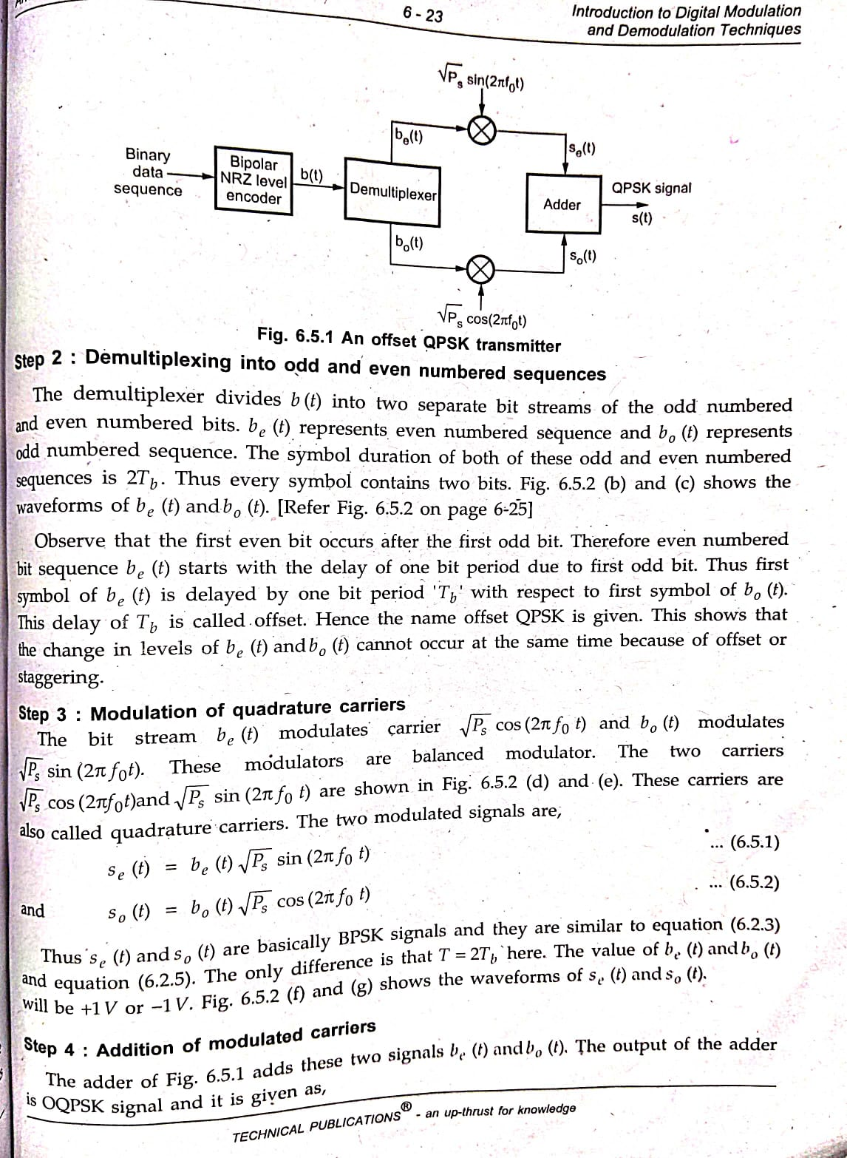
The input binary sequence is first converted to a bipolar NRZ type of signal. This signal is called b (t). It represents binary '1' by +1 V and binary '0' by -1 V. This signal is shown in Fig below
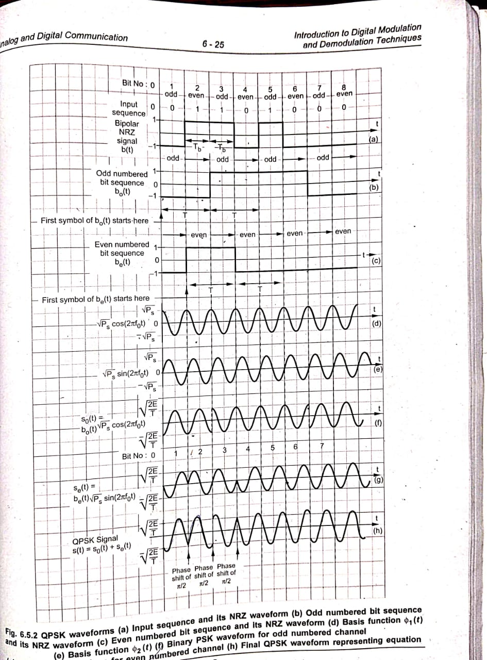
Step 2: Demultiplexing into odd and even numbered sequences
The demultiplexer divides b (t) into two separate bit streams of the odd numbered and even numbered bits. b_{e}(t) represents even numbered sequence and b₀ (t) represents odd numbered sequence. The symbol duration of both of these odd and even numbered sequences is 2T_{b}. Thus every symbol contains two bits. Fig (b) and (c) shows the waveforms of be (t) and b₀(t)
Observe that the first even bit occurs after the first odd bit. Therefore even numbered bit sequence be (t) starts with the delay of one bit period due to first odd bit. Thus first symbol of b_{e}(t) is delayed by one bit period 'T_{b}' with respect to first symbol of b₀(t). This delay of T_{b} is called offset. Hence the name offset QPSK is given. This shows that the change in levels of be (t) and b₀(t) cannot occur at the same time because of offset or staggering.
Step 3: Modulation of quadrature carriers
The bit stream b₀(t) modulates the carrier $\sqrt{P_{S}}$cos(2П$f_{0}$t) and b_{e}(t) modulates $\sqrt{P_{S}}$sin(2П$f_{0}$t).These modulators are balanced modulators.The two carriers $\sqrt{P_{S}}$cos(2П$f_{0}$t) and $\sqrt{P_{S}}$sin(2П$f_{0}$t) are shown in fig (d) and (e )
These carriers are also called quadrature carriers.The two modulated signals are

$s_{e}$(t)= b_{e}(t) $\sqrt{P_{S}}$sin(2П$f_{0}$t)
$s_{o }$(t)=b₀ (t)$\sqrt{P_{S}}$cos(2П$f_{0}$t)
The value of b_{e}(t) and b₀(t) will be +1 V or -1 V. Fig (f) and (g) shows the waveforms of s_{e}(t) and s₀(t).
$s_{e}$(t)= b_{e}(t) $\sqrt{P_{S}}$sin(2П$f_{0}$t)
$s_{o }$(t)=b₀ (t)$\sqrt{P_{S}}$cos(2П$f_{0}$t)

a
Step 4: Addition of modulated carriers
The adder then adds these two signals s_{e}(t) and s₀(t). The output of the adder is OQPSK signal which is shown below and it is given as,
s(t)=s₀ (t)+ s_{e} (t)
=b₀ (t)$\sqrt{P_{S}}$cos(2П$f_{0}$t)+b_{e}(t)$\sqrt{P_{S}}$sin(2П$f_{0}$t)

Step 5: QPSK signal and phase shift

shows the QPSK signal represented by above equation.
In QPSK signal of Fig. (h), if there is any phase change, it occurs at minimum duration of T. This is because the two signals s_{e}(t) and s₀(t) have an offset of 'T_{b}'. Because of this offset, the phase shift in QPSK is $\frac{П}{2}$
It is clear from the waveforms that b_{e}(t) and b₀(t) cannot change at the same time because of offset between them.The following fig shows the phasor diagram of QPSK signal of equation s(t).

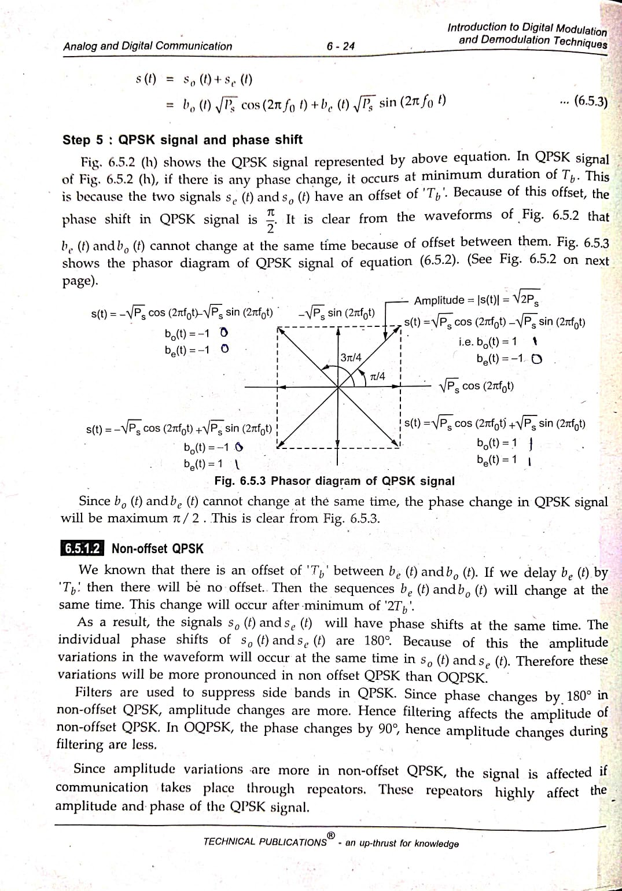
Since b₀(t) and b_{e}(t) cannot change at the same time, the phase change in QPSK signal will be maximum л/2.

QPSK RECEIVER
The following figure shows the QPSK receiver
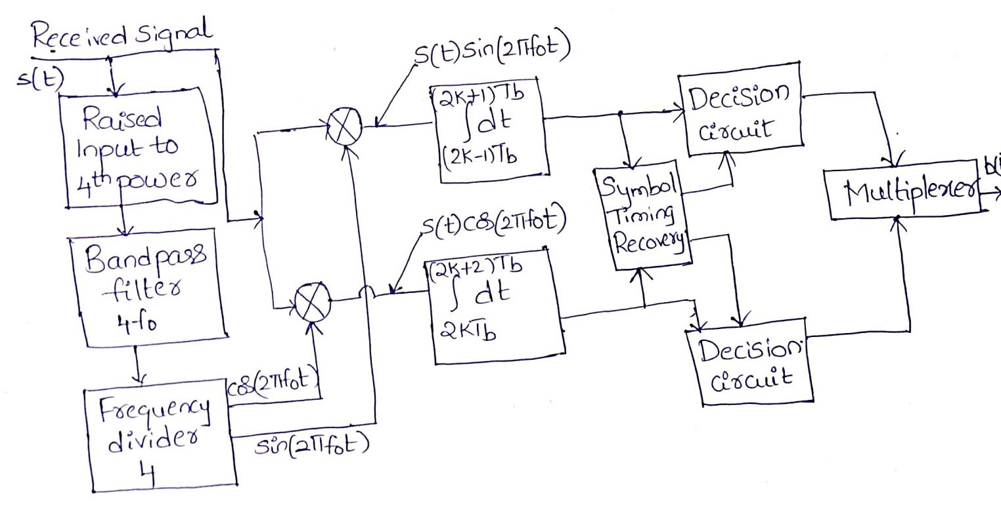

Step 1: Isolation of carrier
The received signal s(t) is first raised to its 4th power, i.e. s⁴(t). Then it is passed through a bandpass filter centered around 4f₀. The output of the bandpass filter is a coherent carrier of frequency 4f₀. This is divided by 4 and it gives two coherent quadrature carriers cos(2Пf₀t) and sin (2Пf₀t):
Step 2: Synchronous detection
These coherent carriers are applied to two synchronous demodulators. These synchronous demodulators consist of multiplier and an integrator.
Step 3: Integration over two bits interval
The incoming signal is applied to both the multipliers. The integrator integrates the product signal over two bit interval (i.e. T_{s}= 2T_{b}).
Step 4: Detection and multiplexing the odd and even bit sequences
The symbol timing recovery circuit recover the clock at the symbol rate or a multiple of symbol rate from the integrated output signal.This clock is required to convert the continuous time received signal into a discrete time sequence of data symbols.At the end of the clock period T_{S}, the output value of integrator is taken(sampled). The output values of the two integrators are taken(sampled) at the offset of one bit period T_{b}. The decision device detects the bit as bit’1’if the output value exceeds the decision threshold else the bit is detected as bit ‘0’. After detection the odd and even sequences are combined by the multiplexer.
To show the output of integrator depends upon respective bit sequence
Let us consider the product signal at the output of upper multiplier
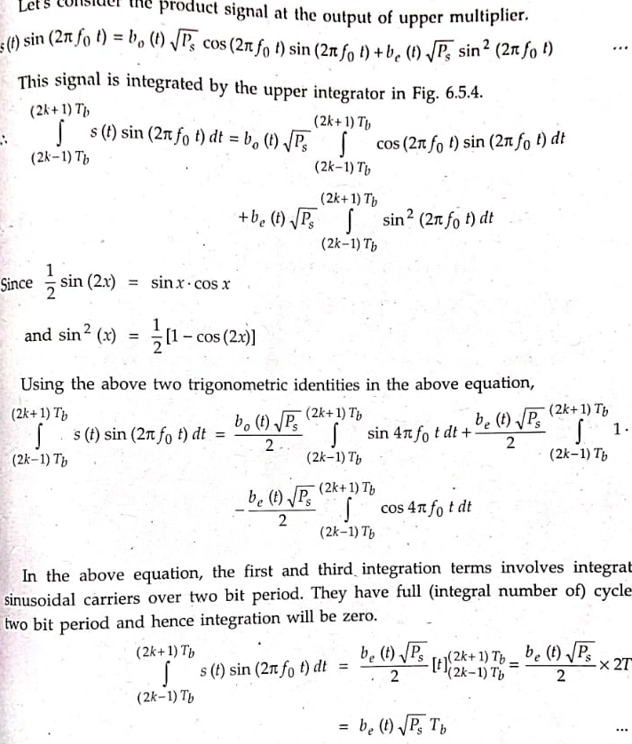
Thus the upper integrator responds to even sequence only.Similarly we can obtain the output of lower integrator as b₀(t)$\sqrt{P_{s}}$T_{b}

